Paying it Forward:
Budgeting for South Pasadena’s Future

A Report By
The South Pasadena Community-Needs-Based Budget Task Force

Elizabeth Anne Bagasao
Jonathan Eisenberg
Barbara Eisenstein
Madeline Di Giorgi
Ella Hushagen
Monica Kelly
William Kelly
London Lang
Steven Lawrence
Jan Marshall
Linda McDermott
Joanne Nuckols
John Srebalus
Helen Tran
South Pasadena Youth 4 Police Reform
John Srebalus
Brandon Yung

July 13, 2020

Creating a Community-Needs-Based Budget for South Pasadena

Unprecedented events have brought the city of South Pasadena, as well of the nation, to a point of crisis and a crossroads that demands fundamental reassessment and change in the very purpose and role of governments. The situation in South Pasadena requires both a change in revenue sources and how funds are allocated in the city budget. Comprehensive changes to make the budget more economically and socially progressive are needed on an urgent basis.

South Pasadena’s New Realities

Today, 16.3 percent of South Pasadena residents are unemployed, according to the California Economic Development Department, and the pandemic shows no sign of abating anytime soon. The recent resurgence of the virus already is threatening the reopening of the economy and shaking public confidence in resuming business and life as usual.
Unemployment in South Pasadena is 16.3 percent, meaning 2,200 residents have lost their jobs, according to the California Economic Development Department.
Even before the pandemic, though, the proliferation of gig employment, two-tiered wage and benefits employment terms, high housing costs, increasing health insurance costs, and other factors already were squeezing many South Pasadena residents. That was true, even though the median household income was more than $96,000 annually in 2018, according to the Southern California Association of Governments. SCAG data show that 35 percent of households in South Pasadena pay 50 percent or more of their income for housing, while the long-held thumb rule for a middle class lifestyle is to pay no more than 30 percent of income on rent or a mortgage. These facts regarding growing inequity were largely left out of recent discussions on city revenue sustainability. Ultimately, though, they doomed the sales tax increase as a true financial sustainability measure even before voters approved it.

Meeting New Community Needs

In light of new community needs growing out of today’s economic and social realities, a group of residents who have been active on city issues—including new leaders among the community’s youth—has studied the proposed 2020-21 budget and concluded that several changes are needed to make progress in South Pasadena on long-stalled projects and to improve economic and social equity, the environment, and transportation. This group, referred to herein as The South Pasadena Community-Needs-Based Budget Task Force, sees the need for a series of specific amendments, directives, and commitments in the budget to move in a more progressive direction. Specifically, the task force is calling for:

New Revenue: It’s time to pay it forward. Place a measure on the November ballot to increase the existing city’s Real Estate Transfer Tax to provide new funds to meet new and growing needs.
Police Reform: Begin to reform the South Pasadena Police Department by shifting resources now dedicated to policing to new types of community peace officers dedicated to serving youth, the homeless, and the mentally ill. To begin the process, the city council should include money and a directive in the proposed budget to carry out a full audit of the Police Department to provide the information needed to begin reallocating resources.
Thirty-five percent of South Pasadena households pay 50 percent or more of their income on rents or mortgages, according to the Southern California Association of Governments. That means more than 3,800 households what SCAG calls “severely cost-burdened.”
Help for Renters: Create a local rental support program to make housing more affordable beginning with reallocation of federal Community Development Block Grant funding appropriated recently for sidewalk repair to a new program for tenants.
Workforce Equity: Direct staff in the budget to develop an ordinance and any program needed to administer it that will raise the minimum wage in South Pasadena to $16.50 per hour, the same as paid at Los Angeles International Airport.
Youth Services: Fully fund after-school and summer childcare services by using more locations for these programs and potentially cooperating with the South Pasadena School District to expand capacity as parents face having to return to work. For older youths, launch a city-backed jobs program to perform useful work that will serve the community while imparting important job and life skills.
Environment: Create more transparency within the city’s budget and accounting system regarding how money for trees, water efficiency, and park maintenance are being used. Also, create and staff as needed a hotline for complaints about water waste, illegal tree cutting, and failure to observe the city’s plastic ordinance, among other standards.
Transportation: Provide money for staff or a consultant to help expedite expenditure of transportation funds on complete street and traffic calming and pedestrian safety programs. In addition, if voters pass the Real Estate Transfer Tax increase, boost funding for street repairs and repaving by at least $500,000 annually.

Building a Durable Revenue Foundation

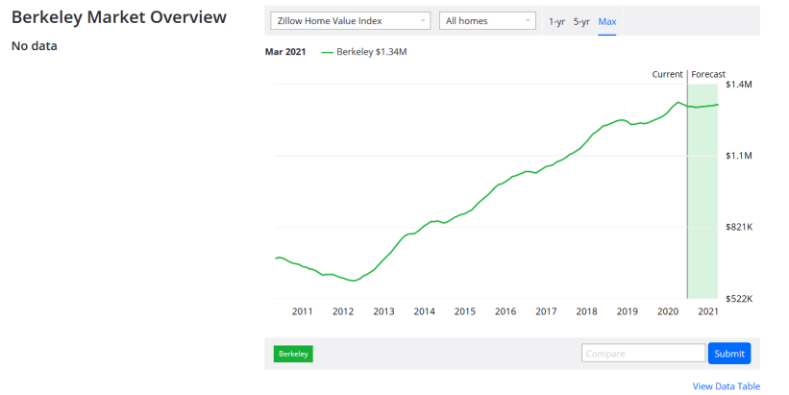
A higher Real Estate Transfer Tax in Berkeley, compared to South Pasadena, hasn’t put a damper on home prices in the Northern California community, Zillow data show.
First and foremost is the need to develop adequate and stable funding. Toward that end, the Task Force recommends that the budget be amended as follows:

- Let’s pay it forward. Property owners who have enjoyed living in South Pasadena and seen their homes appreciate wildly in value can afford to do so. Direct that an increase in the city’s existing Real Estate Transfer Tax be placed before voters this November. South Pasadena’s Transfer Tax, circa the 1950s, appears not to have been reviewed for decades, with its basis at 27.5 cents per $500 of property value, or 55 cents per $1,000. Today, the City of Berkeley’s real estate transfer tax, at its top level, is $25 per $1,000 of property value, 45 times more than South Pasadena’s. Many other cities have higher transfer taxes. Accordingly, the Task Force recommends that the city place on the November ballot, in addition to the Utility Users’ Tax, a graduated real estate transfer tax based on the sale price or valuation of the property when it is transferred as follows:

Property Value | Tax Per $1,000
$100,000 - $999,000 | $10
$1,000,000 - $1,999,999 | $17.50
$2,000,000 or more | $25.00

Initial indications are that a flat $10 per $1,000 tax in 2019 would have raised $2.6 million for the city based on Zillow sales data. A flat $15.00 per $1,000 tax would have raised $3.9 million. However, the Task Force prefers that the tax be structured in a graduated manner and back-casting revenue with a graduated structure exceeds the capacity of the group. Clearly, however, the tax would bring needed revenue to the city in a substantial manner that would allow it to better meet today’s changing needs. In light of the fact that a real estate transfer tax would be a progressive revenue measure, the Task Force believes the ballot measure should say that overnight parking city fees will be revoked if the measure passes and that business licensing fees will be cut in half for the next two years and then reset at an appropriate rate. This will provide at least a modicum of economic relief to South Pasadena residents in exchange for recently passing a sale tax increase and for their additional willingness to renew the utility tax.

- In the proposed budget, provide funds and direct staff to study additional potential revenue sources in the coming year. These could include a transient occupancy tax, with restrictions on Airbnb rentals that reduce the housing supply, and a property vacancy tax, which could bring uninhabited properties back into the housing supply. A number of environmental fees, such as transportation demand charges for commercial plazas and on-site film and TV productions that indirectly generate car and truck trips, should also be explored, particularly to help implement the city’s forthcoming climate change plan and meet climate adaptation needs.

Police Reform & the Budget

The proposed 2020-21 Police Department Budget should be amended. At a proposed level of $9.8 million for the coming fiscal year, the Police Department budget amounts to 35 percent of general fund expenditures and is the biggest single cost to the city’s general fund. Community stakeholder input (performed before George Floyd’s murder triggered nationwide protests and calls to defund police departments) revealed that respondents favored limiting general fund expenditures on police to 26 percent of the general fund, which would amount to $7.25 million out of total proposed general fund spending of $27.88 million.
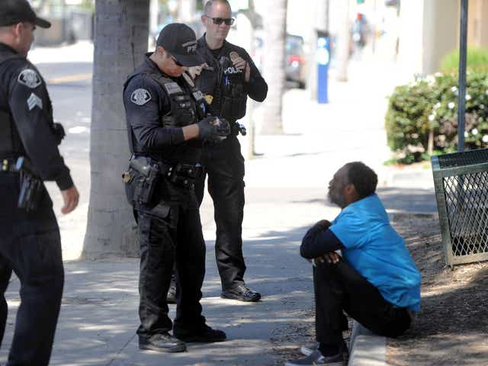
Police deal with unhoused residents, but more say they would be better helped by social workers, health workers, housing navigators, and other specialists.
To every extent possible, the Police Department’s budget should be scaled back in favor of community-based services that promote the health and well-being of a community. This includes social services providers and outreach workers to respond to mental health crises, unhoused neighbors, and drug use in school settings.
The Task Force recommends that the city allocate sufficient funds in the non-departmental expense portion of the budget to hire an independent auditor reporting to a City Council committee with stakeholder input to perform a management audit of the Police Department. It should include developing a profile of what tasks the Department spends its time on, the associated costs, the necessity of patrols, opportunities for savings, operational changes, staffing changes, vehicle usage, the necessity of overtime, etc. The audit also should include a synopsis of crime trends, numbers of crimes solved, how well the force follows written policies and procedures, the state of police training, and other indicators to show how well the department and its budget is being managed. When it is finished, it should be presented to the community. The city should not, however, wait until this audit is completed to reduce the police budget in these specific ways:

- End K9 narco searches at SPUSD campuses by withdrawing them from the school district as a service the city will provide going forward. While the school district reimburses the city for $8,000 of expenses associated with the maintenance and training of a search dog, the city should simply say that it will not offer the service to the school district on any basis.

- Eliminate expenditures for a school resource officer and eliminate the associated position. This will reduce the police budget by some $200,000, which should be shifted to provide support for enhanced counseling and psychological services for the community’s students.

- Minimize expenditures on any police time and money spent on outreach efforts to unhoused individuals and re-allocate these resources to social workers, trained outreach workers, and housing navigators.

Housing & Tenants

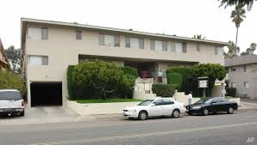
Apartments for rent in South Pasadena begin around $1,600 for a studio, with two bedroom one-bath units beginning at more than $2,400 a month.
Given recent unprecedented events, the Task Force urges you to amend the city’s 2020-21 expenditure plan as follows:

- Due to high housing costs and wage stagnation, the community needs to give a break to renters, which represent half the city’s households, by establishing a rent support program. There is no better place to start than by relocating federal Community Block Grant funds. The City has approximately $241,565 in federal Community Development Block Grant (CDBG) money for fiscal year 2020-21, plus $73,528 in CDBG funding through the CARES Act. The Council voted to allocate $216,567 in CDBG funds to sidewalks and ramp improvements on May 6, and indicated its preference to use the CDBG-CARES funding for senior meals. The Task Force urges the City to allocate the majority of CDBG funds dedicated for sidewalks to a new emergency rental assistance program. In addition, since the senior meal program is well-funded at its current amount with regular CDBG and other funds, the city should reassess whether any of the $73,000 under the CARES Act previously allocated for senior nutrition should be shifted into the new emergency rental assistance fund.

- The City should develop a new housing support program to create more affordable rental units. This can be accomplished by reallocating amounts from a decreased police budget and other sources of revenue as described in this report. Potential forms of support could include subsidizing low-income renters, subsidizing the conversion of existing housing stock to affordable units, and subsidizing landlords who pledge to rent housing to Section 8 and other voucher holders. The imperative for our city to provide affordable housing is high. Our unhoused population in the county continues to grow, increasing by 13 percent to about 66,400 unhoused individuals in the last year (2020 Greater Los Angeles Homeless Count, released June 12, 2020). This increase was before the pandemic and economic collapse, and we need to brace ourselves to help the greater housing needs to come. Los Angeles County needs about 509,000 affordable units to meet the current housing demand for unhoused and under-housed families and individuals. In South Pasadena, we need about 1,150 units of housing for low-income individuals and an additional 300 units for moderate-income individuals (Draft Regional Housing Needs Assessment, Housing Element 2021-2029). We recognize providing affordable housing is only a piece of the solution to the housing crisis, and this is a critical step toward a more comprehensive package of solutions.

- The city should include language in the budget directing staff to seek to recover back tax reimbursements from Caltrans on homes that were removed from the property tax roll when they were taken over by the state to make way for the now defunct 710 Freeway extension. In addition, the city should examine how Caltrans properties could be effectively rehabilitated and converted to provide additional housing stock in South Pasadena, particularly as affordable dwellings.

Workforce Equity

The Task Force recommends the following change in the proposed budget:

- To bolster household income, the Task Force backs amending the budget to provide necessary funding and to direct the staff to develop an ordinance setting a minimum wage of $16.50 per hour, the same as paid at Los Angeles International Airport. The ordinance should authorize enforcement of the wage requirement through private right of action. This is done in the city of Los Angeles and would minimize the burden on the city to administer the wage ordinance.

Environment

The Task Force calls on the city to amend the proposed 2020-21 budget as follows:

- When the South Pasadena Arroyo Seco Woodland & Wildlife Park Nature Park was created, the city agreed to maintain it in perpetuity. Right now, it is largely maintained by volunteers. New signs are needed, as well as additional work by Land Care, which maintains city parks on a contract basis, to remove trash and clear invasive grasses before they go to seed, among other tasks. The amount of the contract with Land Care that is dedicated to the park should be shown in the budget and adjusted to provide for improved maintenance. Also, a separate trail improvement line item should be established to help fund a City Corps program for youths in the community (see below under Youth Services). One of the projects of the City Corps would be to improve the trail along the east side of the Arroyo by the golf course and athletic fields.

- Create a line item in the table showing fund balances that specifies the balance dedicated to tree replacement in the city and shows the revenue collected for tree removal and trimming permits, tree replacement fees paid to the city to plant trees on public property in lieu of replacing trees on properties where they are removed, and donations to the fund. Expenditures should be shown in this line item. The budget also should include a brief narrative discussion explaining how many trees have been planted with the tree replacement fund in the past year and how many are to be planted in the forthcoming fiscal year.

- The city needs to authorize a hotline and a new position to enforce environmental standards for businesses. These should include the city’s ordinance prohibiting sources of air pollution (such as leaf blowers) that create a public nuisance by entraining pollutants into the air that cause ill health, such as asthma and allergies, and damage property and impose costs on residents, such as dust that soils cars, patio furniture, home exteriors, etc. The position also is needed to enforce existing restrictions on use of Styrofoam and plastic bags, as well as to enforce an upcoming ban on other single-use plastics. The enforcement position is further needed to better enforce restrictions aimed at preventing waste of water, as well as illegal removal of trees.

Youth Services

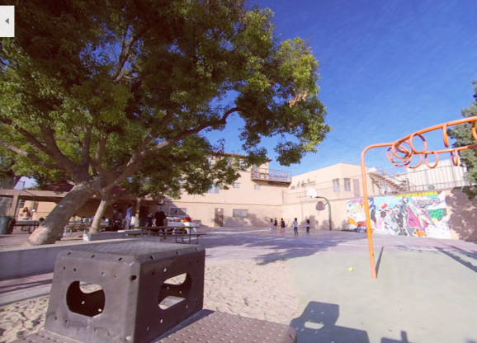
Pandemic standards have reduced the childcare capacity at Orange Grove Park, the traditional site of the city’s Camp Med program. Yet, the program could be expanded to meet demand by using other readily available facilities.
To support the welfare and development of the community’s youth, the Task Force recommends the city amend the proposed budget to:

- Restore full funding, or even expanded funding, for after-school care and summer camp programs run by Camp Med, as well as library reading programs, though Zoom if necessary. As parents face having to return to their work places, the community will soon face a childcare crisis at the current budgeted level. The problem will become additionally acute under planned cuts to the school district’s after school care program. Granted, health directives regarding the pandemic constrain the capacity of the Camp Med program as it has been run in the past at Orange Grove Park. However, since much of the program is covered by parent-paid fees, there is little reason not to expand the number of locations where Camp Med services can be offered, beyond the current plan to operate at Orange Grove and the Eddy Park House. Additional facilities, such as the War Memorial Building, the vacant room at the golf course, and the Garfield Park Scout House could be used. In addition, the city could cooperate with the school district through a joint program or even rent spaces for an expanded program, such as the Women’s Club, vacant commercial buildings, or other facilities in the city.

- If a real estate transfer tax is passed by voters in November, create a City Corps program to provide summer and part-time jobs during the school year to youths in the community. The Task Force suggests initially budgeting $500,000 for a City Corps program, plus an additional city staff position to organize and oversee the operation. In addition, the budget should include an increase sufficient to pay for supplies and tools needed to employ City Corps workers. At $16.50 per hour, the program could fund more than 30,000 hours of useful work to improve the community, including trail improvements, filling potholes, data entry, tree planting, community outreach, water conservation landscaping on medians and in parks, library work, and painting, minor wood and roof repair, and landscaping of deteriorating homes in which elderly people with limited incomes reside. Up to 100 youths could be employed, each earning some $3,000 annually. The City Corps would help teach youth valuable skills and impart the work ethic. The Task Force suggests that half the positions go to underprivileged youth.

Transportation & Pedestrian Safety

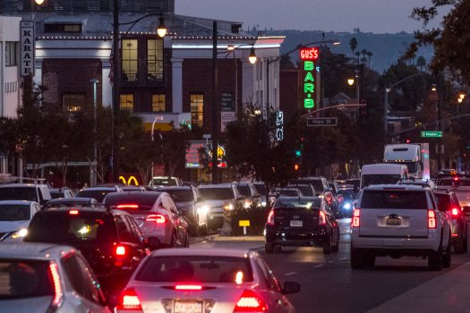
Traffic controls, traffic calming, and complete streets projects need to be accelerated in South Pasadena, where gridlock occurs regularly and cars endanger pedestrians at many intersections.
The Task Force urges the city to amend the budget as follows:

- Fund staff and/or a consultant to help expedite expenditure of transportation funds on complete street and traffic calming and pedestrian safety projects. Sufficient staffing also is needed to better coordinate with surrounding cities on projects that smooth traffic flow in the sub-region and interconnect, for instance, bike trails. Slater Fund money could potentially be appropriated for this.

- If a real estate transfer tax is passed by the voters, amend the annual budget to increase general fund spending on street repairs and repaving and complete streets projects by $500,000 to $1 million to accelerate repairs of crumbling and pothole-filled streets in residential neighborhoods and improve street lighting.

Conclusion

Adopting the budget amendments and measures outlined by the Task Force will provide the revenue the city needs to meet the new and urgent economic and social needs of community residents. Many of these needs have long been unaddressed and are growing increasingly urgent. It’s time to pay it forward South Pasadena. Your bold action is needed today.

